[https://youtu.be/pVQGVP9IrxY](https://youtu.be/pVQGVP9IrxY" \t "_blank)

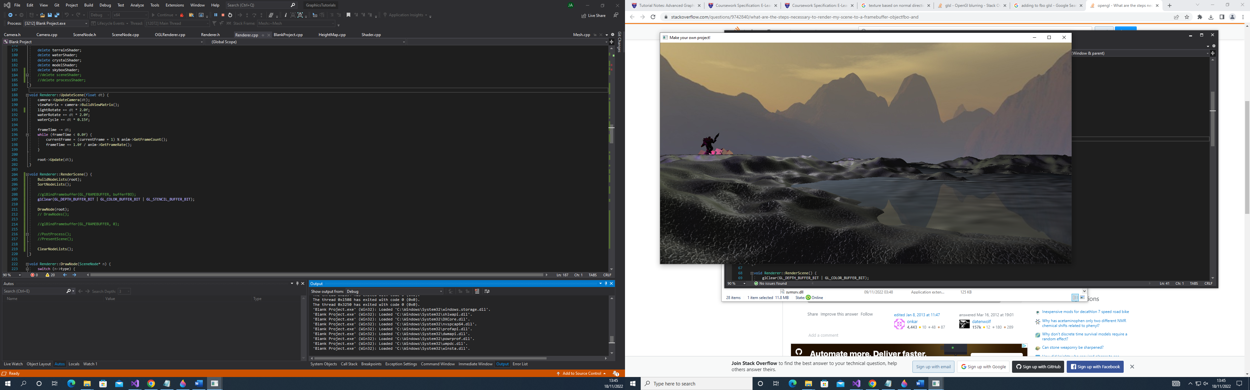

The scene contains a skybox with terrain rendered from a texture-based height map. There are two lights in the scene: a very large which light which rotates, creating a day-night cycle and a much smaller pink light which illuminates the crystals, character and terrain and water in the area.

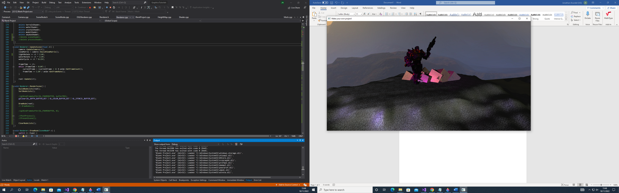

There is an animated character next two some cubes designed to look like crystals. The crystals are textured using tri-planar mapping. They reflect the skybox, and they have transparency when viewed up close but are opaque from a distance. These are also lit by both lights present in the scene.

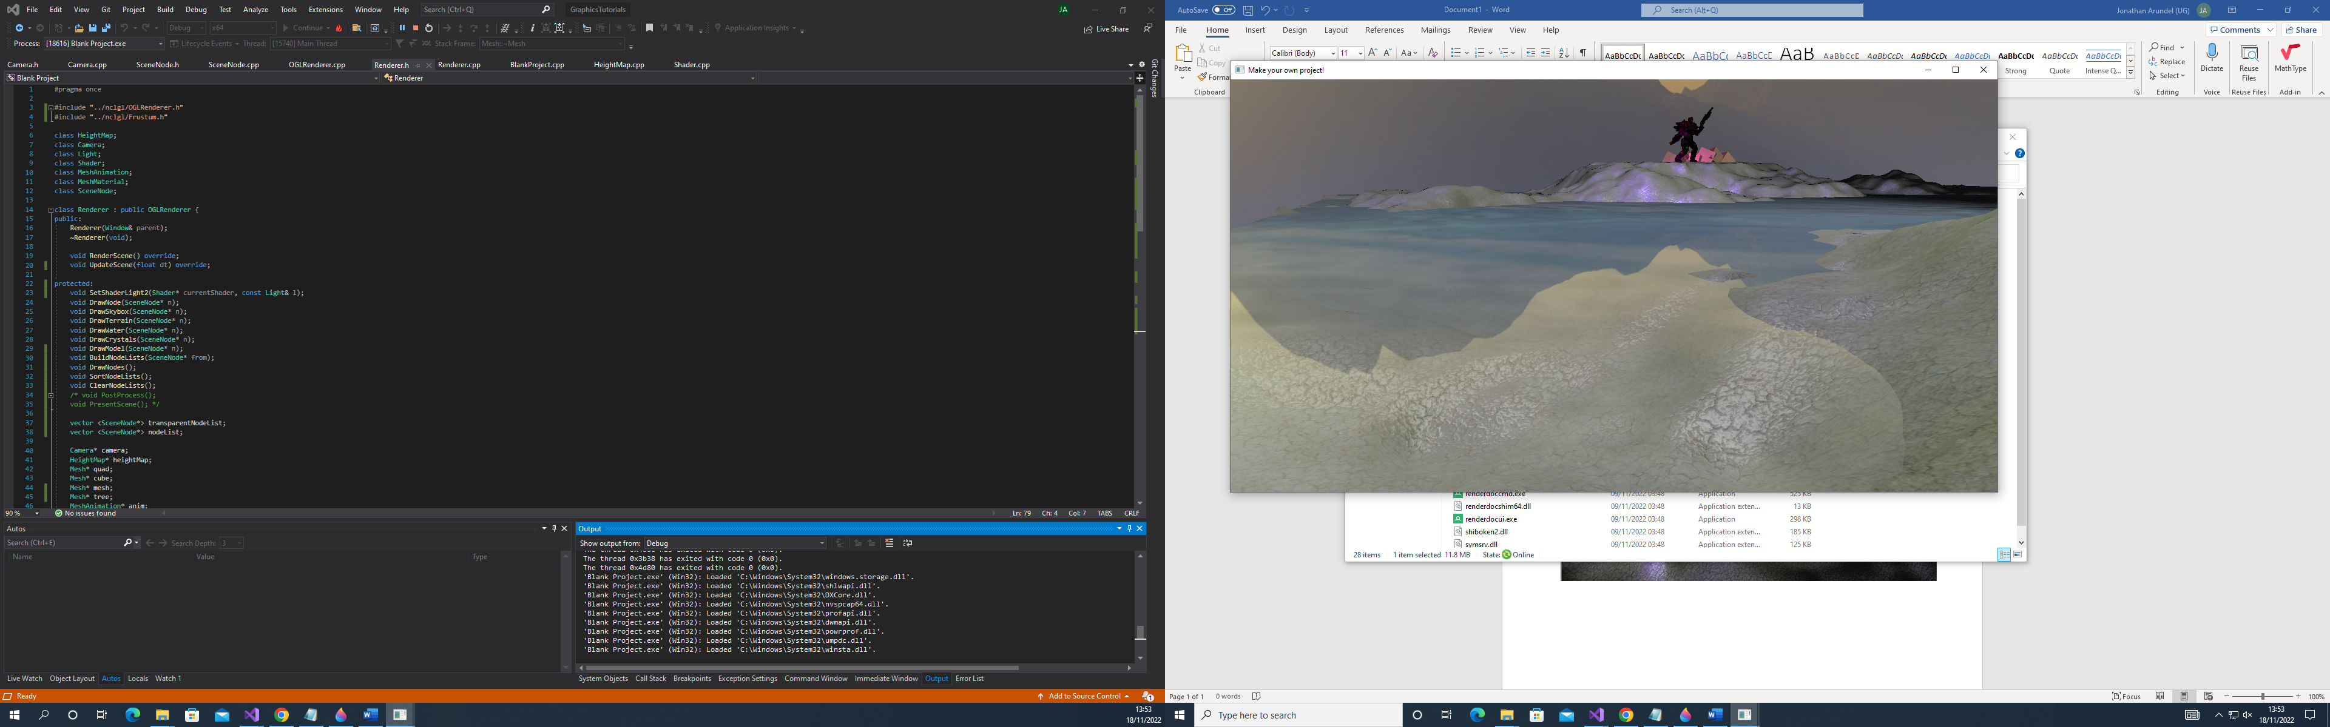

The water is textured in a very similar way to the crystals. It does not make use of tri-planar mapping, however. It is lit by both lights in the scene, has a bump map and the texture moves and rotates as the scene progresses. The water also makes use of environment mapping, using the following texture to display two different water textures on the water. It has the same effect as the crystals where up close it is transparent and further away it is opaque, this effect is far more obvious on the water.

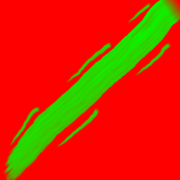

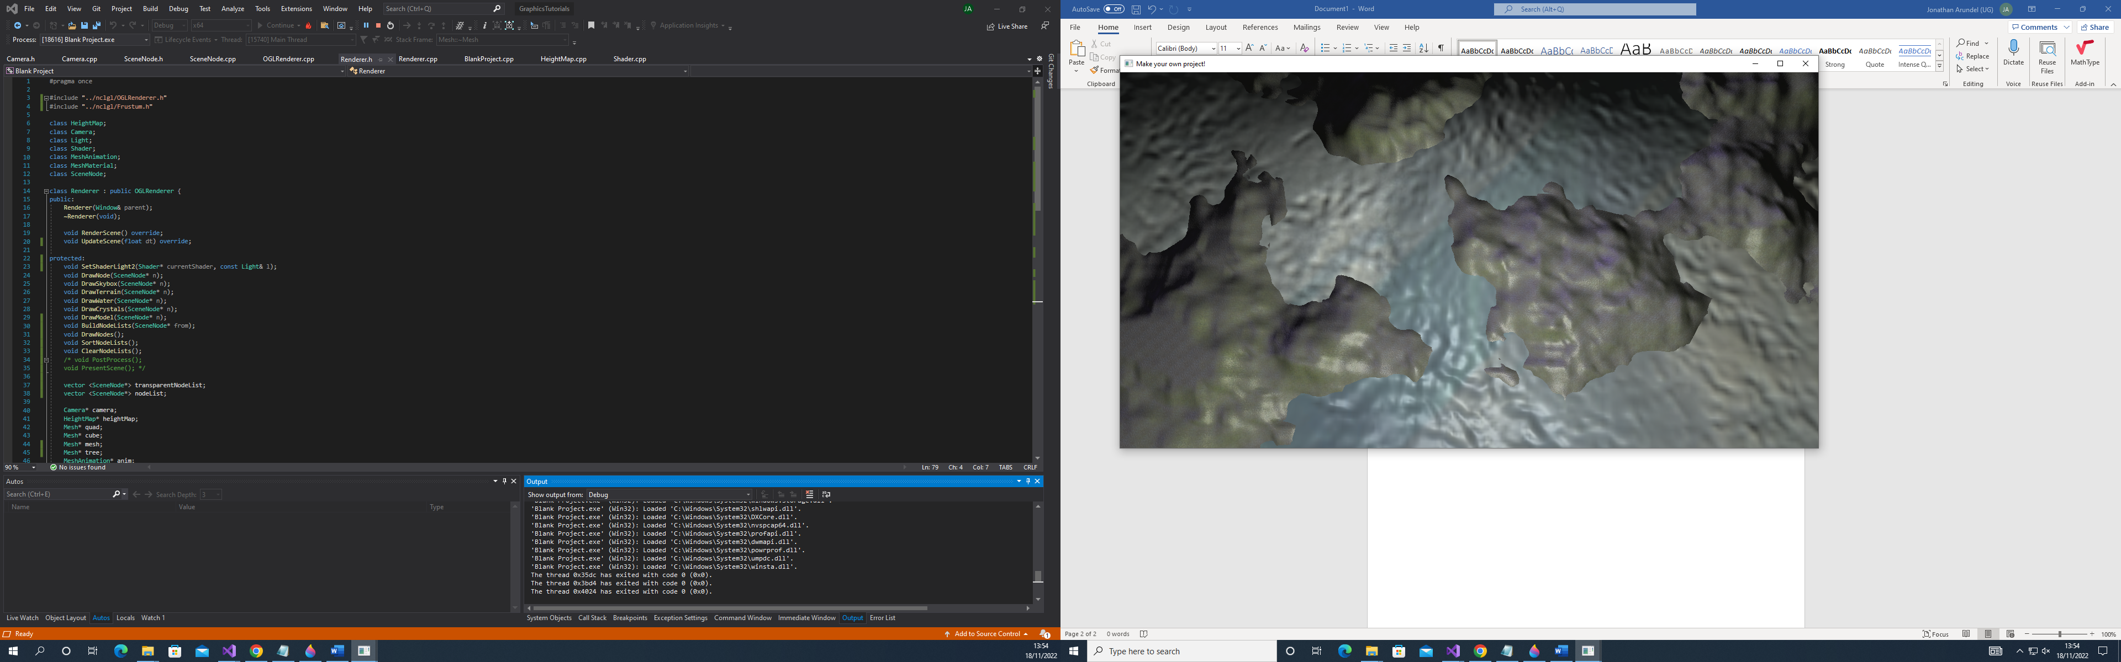

The terrain is also textured using tri-planar mapping. Below the water surface the terrain is exclusively covered in a rocky texture, while above the surface a blend between a rocky and grassy texture is used based upon the normals of the terrain. The terrain is lit by both lights.

Camera Controls:

WASD – for moving forwards/backwards and left/right

Space – for moving up

Shift – for moving down

M – to increase camera movement speed

N – to decrease camera movement speed